

FEASIBILITY REPORT

***<NAME OF THE ASSIGNMENT>***

***<PLANT DETAILS>***

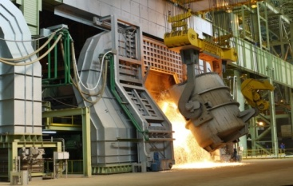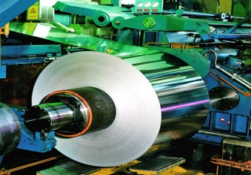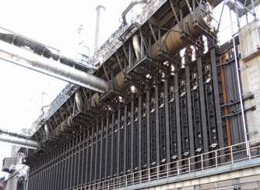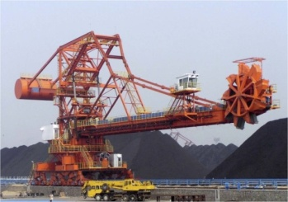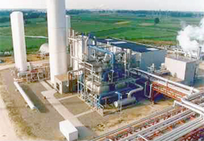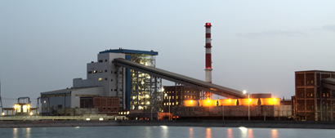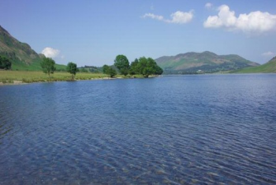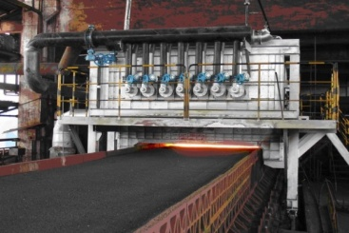

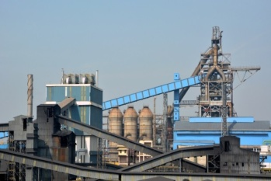





**STEEL AUTHORITY OF INDIA LIMITED**

**CENTRE FOR ENGINEERING & TECHNOLOGY**

**RANCHI - 834002**

**<MONTH YYYY> <Document no.>**

**This document has been prepared for <XYZ> by:**

Centre for Engineering & Technology

<Name of HOD> – HOD Lead section

<Name of Task Force Leader> (Task Force Leader)

<Name of TFM 1>, <Discipline >

<Name of TFM 2>, <Discipline >

<And so on.>

|  |  |
| --- | --- |
| Document Identification No. | ***<Document No.>*** |

**REVISION HISTORY**

|  |  |  |
| --- | --- | --- |
| **Revision No.** | **Brief Description** | **Revision Date** |
| R3 |  |  |
| R2 |  |  |
| R1 |  |  |

*Disclaimer*

*This document is the property of CET and is exclusively for the use of the intended client. This document has been prepared based on the inputs provided by the client. No part of this report shall be reproduced or transmitted in any form whatsoever without the written permission from the owner.*

**UPSHOT**

<An executive summary of the entire aspects of this report>.

*<*

*example:*

*Due to various problems experienced by DSP for Boiler No. 7, a new boiler of capacity 100tph has been proposed. This project will be commissioned in X months from the date of stage II approval. The estimated capital cost is Rs.XXXX at an IRR and NPV of YYYYY.*

*>*

**CONTENTS - CHAPTERS**

|  |  |  |
| --- | --- | --- |
| **Chapter no.** | **Description** | **Page no.** |
| 1 | Summary |  |
| 2 | Background |  |
| 3 | Selection of Alternatives |  |
| 4 | Project Description |  |
| 5 | Implementation Schedule & Strategy |  |
| 6 | Capital Cost & Financial Analysis |  |
| 7 | Recommendations |  |
|  | Annexures |  |
|  | Drawings |  |

**ANNEXURES**

|  |  |  |
| --- | --- | --- |
| **Annexure No.** | **Description** | **No. of pages** |
|  |  |  |
|  |  |  |
|  |  |  |
|  |  |  |
|  |  |  |
|  |  |  |

**DRAWINGS**

|  |  |  |
| --- | --- | --- |
| **Sl. No.** | **Drawing No.** | **Description** |
|  |  |  |
|  |  |  |
|  |  |  |
|  |  |  |
|  |  |  |
|  |  |  |

1. **SUMMARY**
2. **BACKGROUND**
3. **SELECTION OF ALTERNATIVES**
4. **PROJECT DESCRIPTION**
   1. **RISK ASSESSMENT**
      1. Risk assessment for the project is attached at **Annexure- 4.12.1-1**
   2. **SAFETY**
      1. Safety Factors to be Considered during Designing
      2. Safety Measures to be Considered during Implementation of the Project
   3. **OPERATIONAL AND MAINTENANCE SPARES FOR TWO YEARS**

**Operational & maintenance for two years have been considered/ not considered in the scope of work.**

***NOTE*** *- Please note that the number of the paragraphs which is shown as 4.12, 4.13 & 4.14 above may vary from FR to FR depending on the number of paragraphs that are required to be written above it. Consequently, the annexure number will also change. A sample of the annexure (Risk Assessment register) is attached with this document.*

1. **IMPLEMENTATION SCHEDULE AND STRATEGY**

5.1 **IMPLEMENTATION SCHEDULE**

5.1.1 The project is envisaged to be implemented within a period of _____ months from the date of Stage-II approval. Pre-ordering activities are envisaged to be completed within ______months from the date of Stage-I approval.

(The duration for completion of project from Stage-II approval is to be finalized based on evidence of probable bidders’ information/ evidence of actual duration in similar projects executed in the past, if any)

5.1.2 Implementation schedules, in the form of bar charts, for pre-ordering and post-ordering activities are shown at **Annexure – 5.1.2-1** & **5.1.2-2** respectively.

5.2 **IMPLEMENTATION STRATEGY**

5.2.1 Mode of execution and number of packages:

The project is proposed to be executed through ___ (number) package(s) as follows:

1. Soil survey and geo-technical study/ NDT/ Location of underground facilities (as may be applicable for the current project) – on Turnkey/ Non-turnkey basis and through LTE mode as per empanelment

(TS for the above works, wherever applicable, is to be submitted to client along with the FR)

2. ____________________(Package-II) – on Turnkey/ Non-turnkey basis. **Consortium bidding is envisaged/ not envisaged at this stage.**

3. ____________________(Package-III ) – on Turnkey/ Non-turnkey basis. **Consortium bidding is envisaged/ not envisaged at this stage.**

(Inter-dependency between different packages, as may be applicable or relevant, and details of battery limits for each of the packages to be described here)

5.2.2 Pre-requisites/ clearances, special handling eqpt., diversion of any known over ground or underground facilities that need diversion, etc. for execution of the project:

a) _______________________

b) _______________________

c) _________________________________________

5.3 **DETAILS OF PRE-SHUTDOWN ACTIVITIES WITH DURATION**

(Details of all pre-shutdown activities, if any, and their duration to be described in this para with evidence of discussion with plants (MOM) and also to be shown in implementation schedule.)

5.4 **DETAILS OF SHUTDOWN ACTIVITIES WITH DURATION**

(Details of all shutdown activities, if any, their durations to be described in this chapter with evidence of discussion with plants (MOM) and also to be shown in implementation schedule.)

(Whichever para or sub- para mentioned above is not applicable or relevant for the subject FR, it should be marked as “Nil” instead of deleting it).

1. **CAPITAL COST & FINANCIAL ANAYLSIS**

* **Blue Text with yellow background: Instructions for the respective write-up.**
* **Optional content in grey background: These are optional and will only be part of the write-up in specific cases.**
* **Green background : This needs to be updated for specific project** 
  1. **CAPITAL COST ESTIMATES:**
     1. Capital cost of the Project is estimated at **Rs. 961.02 Crore** (net of Input Tax Credit of Rs.103.32 Crore) on base date of **2nd Quarter, 2020**, including IDC of Rs.52.78 Crore, FE component of Rs.180.12 Crore which includes a component of Rs.55.15 Crore on account of provision for Forward Premium. FE parity has been considered as follows:

|  |  |  |  |
| --- | --- | --- | --- |
| **Currency** | **Current currency rate** | **Forward premium rate** | **Currency rate including forward premium** |
| 1USD= INR | 74.78 | 10.83 | 85.61 |
| 1EURO=INR | 85.56 | 12.33 | 97.89 |
| 1POUND=INR | 94.80 | 13.85 | 108.65 |

The summary of capital cost estimate of the project is as below:

**(Rs. in Crore)**

| **Sl.**  **No.** | **Item** | **Indigenous**  **Component** | **Imported**  **Component** | **Total**  **Amount** |
| --- | --- | --- | --- | --- |
| 1 | Plant & equipment including technological structures | 344.00 | 137.23 | 481.23 |
| 2 | Spares | 10.32 | 4.12 | 14.44 |
| 3 | Building Structures | 72.62 |  | 72.62 |
| 4 | Refractories |  |  |  |
| 5 | Civil Works | 91.40 |  | 91.40 |
| 6 | Erection & Commissioning | 48.15 |  | 48.15 |
| 7 | Engineering & Construction | 62.27 | 19.84 | 82.11 |
| 8 | Freight & Insurance | 25.23 | 9.89 | 35.12 |
| 9 | Taxes & Duties | 132.64 |  | 132.64 |
| 10 | Others | 0.46 | 0.46 | 0.92 |
| 11 | Contingencies | 39.35 | 8.58 | 47.93 |
| 12 | Charges for engaging environmental Consultant, Fee for consent to establish and provision for compliance to EC conditions & towards Enterprise Social Commitment | 5.00 |  | 5.00 |
| **13** | **Total Plant Cost** | **831.44** | **180.12** | **1011.56** |
| 14 | IDC |  |  | 52.78 |
| **15** | **Capital Cost** |  |  | **1064.34** |
| 16 | Input tax credit (ITC) |  |  | 103.32 |
| **17** | **Capital Cost net of ITC** |  |  | **961.02** |

**Optional content in grey text**

In case, where management is required to take strategic investment decisions based on the respective cost of the various packages, the package wise cost may be reported after deliberation between TFL and HOD-CTE. Example of the same is the installation of STP at BSL where the prohibitive cost of Package 2 for tertiary treatment of output of STP water without any appreciable benefits associated with the same may lead to the rethink by the management as regard the usage of water within the plant.

**Package wise breakup may be given as shown in Clause 6.1.2 as below**

* + 1. **Package wise break-up of the summary capital cost estimate**
       1. Main Package:

**(Rs. in Crore)**

| **Sl.**  **No.** | **Item** | **Indigenous**  **Component** | **Imported**  **Component** | **Total**  **Amount** |
| --- | --- | --- | --- | --- |
| 1 | Plant & equipment including technological structures |  |  |  |
| 2 | Spares |  |  |  |
| 3 | Building Structures |  |  |  |
| 4 | Refractories |  |  |  |
| 5 | Civil Works |  |  |  |
| 6 | Erection & Commissioning |  |  |  |
| 7 | Engineering & Construction |  |  |  |
| 8 | Freight & Insurance |  |  |  |
| 9 | Taxes & Duties |  |  |  |
| 10 | Others |  |  |  |
| 11 | Contingencies |  |  |  |
| **12** | **Total Plant Cost** |  |  |  |

* + - 1. Wagon weighing station cum rail tracks package

**(Rs. in Crore)**

| **Sl.**  **No.** | **Item** | **Indigenous**  **Component** | **Imported**  **Component** | **Total**  **Amount** |
| --- | --- | --- | --- | --- |
| 1 | Plant & equipment including technological structures |  |  |  |
| 2 | Spares |  |  |  |
| 3 | Building Structures |  |  |  |
| 4 | Refractories |  |  |  |
| 5 | Civil Works |  |  |  |
| 6 | Erection & Commissioning |  |  |  |
| 7 | Engineering & Construction |  |  |  |
| 8 | Freight & Insurance |  |  |  |
| 9 | Taxes & Duties |  |  |  |
| 10 | Others |  |  |  |
| 11 | Contingencies |  |  |  |
| **12** | **Total Plant Cost** |  |  |  |

**Optional content in grey of clause 6.1.2 as above. Optional contents ends here.**

* + 1. Broad break-up of basic cost of “Plant & equipment including technological structures” of the project is as below:

| **Sl.**  **No.** | **Item** | **Indigenous**  **Component** | **Imported**  **Component** | **Total**  **Amount** |
| --- | --- | --- | --- | --- |
| 1 | Mechanical |  |  |  |
| 2 | Utilities |  |  |  |
| 3 | Electrical |  |  |  |
| 4 | Process Control and Automation |  |  |  |
| **5** | **Total “Plant and Equipment including technological structures” Cost** |  |  |  |

* + 1. Capital cost estimate has been prepared based on Bill of Quantity (BOQ) as per scope of work. The detailed break up is as above. The cost estimate has been prepared considering available budgetary quotations (BQs), purchase orders (POs) and engineering estimate (based on updated cost database). However, the major component of the plant & equipment cost estimate is BQ/ PO.

The cost of gas boosters which is major cost element is based on BQ of M/s TLT Engineering ltd. of December 2018. The BQ of M/s TLT has been considered without any knockdown or escalation.

Civil cost estimate is based on DSR-2018 rates.

Structures cost is estimated based on prevailing market rates.

In total cost estimate of Plant & equipment, 80% is based on BQ/PO and 20% is based on engineering estimate.

Breakup of basic cost of the project in percentage is depicted in the pie-chart shown below.

* + 1. Estimated block cost of some of the major technological units are as follows: (as far as possible in major projects only)

**Optional content in grey text**

**Note: The unit wise costs shall be part of write-up only in specific cases where different units (Say, BOF, Ladle furnace, Caster, etc.) are part of the same package.**

| Sl. No. | Description of units | Estimated block cost (in Rs. Cr.) | Remarks |
| --- | --- | --- | --- |
| 1 | 1x165t HMDS unit with auxiliaries |  | The unit wise estimated block cost is indicative only to give a general idea. |
| 2 | 1 x 165t LD Convertor (BoF) |  |
| 3 | 1 x Twin LF of 165 Ton |  |
| 4 | 1x165t RH-OB unit with auxiliaries |  |
| 5 | 1x Slab Caster |  |
| 6 | Calcined Lime and Dolo plant |  |

* + 1. Necessary additional provisions have been made in the estimates as per the details given below:
       - 1. For indigenous items:

GST @18% on basic cost of equipment, structures, refractory, civil, erection and E&C (Contractor’s), freight & insurance, supervision and training.

* + - * 1. For imported items:

Ocean freight & insurance: @7% on FOB cost;

CD @ 5% on (CIF);

GST @ 18% on (CIF+CD);

Income Tax @ 11.11% grossed up for value of foreign services;

GST @18% on value of “basic cost + income tax” for foreign services;

* + - * 1. Freight & Insurance charges: @ 2% of basic cost of indigenous equipment and 9% of basic cost of structures and refractory. Inland freight & Insurance charges for imported item has been taken @ 3%.
        2. Erection & commissioning charges: @ 12% of basic cost of indigenous equipment & refractory, @ 20 % of basic cost of structures and 6% on CIF cost of imported equipment.
        3. Engineering & construction (E&C): E&C (contractor) @ 5% and E&C (owner) @ 2.5 % on basic cost of equipment, refractory, structures, civil work and erection & commissioning charges.
        4. Contingencies: @ 5 % on overall basis has been considered.
        5. EIA/EMP and CER cost has also been included in the capital cost as per guidelines.
  1. **MODE OF FINANCING:**
     1. The total capital requirement of the project is proposed to be provided from 100% debt. An interest rate @ 10% per annum is considered for commercial borrowing.
  2. **PHASING OF CAPITAL EXPENDITURE & IDC:**
     1. With the project duration of 26 months from the date of stage-II approval, phasing of capital expenditure and IDC is proposed as indicated below:

**(Rs. in Crore)**

| Years | Internal Resources | Loan | IDC | Total |
| --- | --- | --- | --- | --- |
| 1st Year |  |  |  |  |
| 2nd Year |  |  |  |  |
| 3rd Year (2 Months) |  |  |  |  |
| Post Comm. |  |  |  |  |
| **Capital Cost** |  |  |  |  |
| ITC |  |  |  |  |
| **CC net of ITC** |  |  |  |  |

* + 1. Based on the mode of financing and phasing of capital expenditures indicated above, the total IDC works out to **Rs.52.78 Crore**.
  1. **COST-BENEFIT ANALYSIS:**

*Note: No Annexures w.r.t Cost Benefit analysis shall be part of the report as all information will be part of the main body in tabular format.*

*There are two cases:*

***Case-A:*** *Projects where financial analysis cannot be carried out as the benefits arising out of the project cannot be quantified or in cases where the gross margin is not sufficient to establish financial viability.*

***Case-B:*** *Projects where financial analysis can be carried out.*

***For case-A,*** *the cost benefit analysis head of chapter-6 should be suitably augmented in consultation with TFL of the project by enumerating the non-quantifiable benefits in details and also stating the facts such as, if the project is a necessity for reasons of* ***safety****,* ***environment****,* ***sustenance/ obsolescence*** *aspects.*

***For Case-B,*** *Sample Cost Benefit analysis is depicted below:*

* + 1. The proposed project envisages a capacity of Bar mill to be **10,00,000 tpa**. Considering the input billet cost as @ **Rs.31157/t** and corresponding expenditures including manpower cost, consumables etc. the cost of production of TMT works out to **Rs.33512/t**. Details of cost of production calculations are as below:

| SL. NO. | DESCRIPTION | UNIT | QTY | RATE | AMOUNT Rs. in Crore |
| --- | --- | --- | --- | --- | --- |
|  | **Material Cost** |  |  |  |  |
| 1 | Cast Billet from Billet Casters of DSP | t | 10,41,667* | 31,157 | 3,245.49 |
|  | **Total Cast billets** | **t** | **10,41,667** |  | **3,245.49** |
|  | **Operating Cost** |  |  |  |  |
| 2 | Manpower-224 (Exe-16, Skilled-162, Un Skilled 62) |  |  |  | 14.23 |
| 3 | Power- 110 kWh/t | Mwh | 1,10,000 | 6,183 | 68.01 |
| 4 | Specific Energy Requirement (Mixed gas)-0.3 Gcal/t | G. Cal | 3,00,000 | 1,199 | 35.97 |
| 5 | Strapping Material | Kg/t | 10,30,000 | 70 | 7.21 |
| 6 | Water-1 m3/t | Th.cu-m | 1,000 | 20,360 | 2.04 |
| 7 | Roll & Guides | LS | 0 | 0 | 29.26 |
| 8 | Repair & Maint, Stores and spares & Miscellaneous @2.5% of CCNITC | LS |  |  | 20.86 |
| 9 | Scrap Credit | t | 33,333 | 24,437 | -81.46 |
| 10 | Works Overhead |  |  |  | 9.61 |
| 11 | **Sub Total Operating Cost** |  |  |  | **105.73** |
| 12 | **Total Operating Costm (1+11)** |  |  |  | **3,351** |
| 13 | **Production Cost/t** | **Rs/t** |  |  | **33,512** |

**\* Yield considered @ 96% on total finished production of 10,00,000t billets.**

* + 1. In the Gross Margin calculation, NSR of TMT bar has been taken as **Rs.35768/t** and the same has been compared with the cost of production. Based on above, the gross margin works out to **Rs.225.61 Crore.** Details of gross margin calculations are as below:

| **Sl. No.** | **Item** | **Ann Qty (t)** | **Unit works cost Rs./t** | **Annual Manuf. Expenses Rs. Cr.** | **NSR (Commercial) Avg.** | | **Annual NSR Rs. Cr** |
| --- | --- | --- | --- | --- | --- | --- | --- |
| 1 | TMT bars | 1000000 | 33512 | 3351.22 | 35768 | | 3576.84 |
| 1 (a) | **Total** | **1000000** |  | **3351.22** |  | | **3576.84** |
| **1 (b)** | **GROSS MARGIN** |  | | | |  | **225.61** |

* 1. **FINANCIAL ANALYSIS: (only if Cost Benefit analysis has been carried out)**
     1. Financial analysis has been carried out on the basis of cash flow during 22 years. Life of the project is considered 20 years after its commissioning.
     2. Techno-economic indices are furnished below:

|  |  |  |  |
| --- | --- | --- | --- |
| **Sl. No.** | **Description** | **Unit** | **Value** |
| 1 | Capital Cost (Net of ITC) | Rs. crore |  |
| 2 | Gross Margin | Rs. crore |  |
| 3 | NPV @ 10% discount rate (Post-tax) | Rs. crore |  |
| **4** | **IRR (Post-Tax)** | **%** |  |

* 1. **SENSITIVITY ANALYSIS:** 
     1. Sensitivity analysis has been worked out to assess the impact of variations in capital cost and gross margin on the financial indices of the Project and the results are presented below:
     2. **Increase in capital cost**

|  |  |  |  |  |
| --- | --- | --- | --- | --- |
|  | **Base case** | **5%** | **10%** | **15%** |
| Project NPV (post tax)  (@10%) (in Rs. crore) |  |  |  |  |
| Project IRR (post tax) |  |  |  |  |

* + 1. **Reduction in gross margin**

|  |  |  |  |  |
| --- | --- | --- | --- | --- |
|  | **Base case** | **(-) 5%** | **(-) 10%** | **(-) 15%** |
| Project NPV (post tax)  (@10%) (in Rs. crore) |  |  |  |  |
| Project IRR (post tax) |  |  |  |  |

* + 1. **Increase in capital cost and reduction in gross margin combined**

|  |  |  |  |
| --- | --- | --- | --- |
|  | **Increase by 5% & Reduction by 5%** | **Increase by 10% & Reduction by 10%** | **Increase by 15% & Reduction by 15%** |
| Project NPV (post tax)  (@10%) (in Rs. crore) |  |  |  |
| Project IRR (post tax) |  |  |  |

* + 1. **Delay in Project**

|  |  |  |  |  |
| --- | --- | --- | --- | --- |
|  | **6 months** | **12 months** | **18 months** | **24 months** |
| Expected loss of gross margin (Rs. Cr.) |  |  |  |  |

Note: Any other parameter on which sensitivity analysis is required to be done the same will be carried out as per the requirement of specific project.

1. **RECOMMENDATIONS**

**ANNEXURE - <no.>**

**RISK ASSESSMENT REGISTER *(this is a only a sample)***

|  |  |  |  |  |  |  |  |  |  |  |  |  |
| --- | --- | --- | --- | --- | --- | --- | --- | --- | --- | --- | --- | --- |
| **SL** | **ISSUES** | **RISK** | **PROBABILITY (H/M/L)** | **CONSEQUENCE (H/M/L)** | **Risk Priority Number (RPN) (DxE)** | **Current controls** | **Additional Actions** | **Responsibility** | **Implementation date** | **Revised probability (H/M/L)** | **Revised consequence (H/M/L)** | **Revised Risk Priority Number (RPN)**  **(KxL)** |
| **A** | **B** | **C** | **D** | **E** | **F** | **G** | **H** | **I** | **J** | **K** | **L** | **M** |
| 1 | Shutdown of more than one section out of 3 sections during erection of new section | Operation of Blast furnaces will hampered due lone running section | L | H | L3 | - | 1. HT cables from 3RP swbd to new section shall be laid and terminated at new section end prior to taking shutdown to minimize shutdown duration 2. Preventive maintenance of switchboards should be carried out prior to taking shutdown of one section out of 3 sections | Contractor & BSL  BSL | - | L | H | L3 |

Legend:

|  |  |  |
| --- | --- | --- |
| **C:\Users\MR.MISHRA.CETSAIL\Desktop\Untitled.png** | **Note:**  **Column “B”:** Issues identified  **Column “C”:** Risk corresponding to the above issue  **Column “D”:** Probability of occurrence of the risk (H-High, M-Medium & L-Low)  **Column “E”:** Consequence (H-High, M-Medium & L-Low) | **\*Note:**  The **Risk Priority Number (RPN)** can be Level- 1 (L- 1), Level- 2 (L-2), L-3, L- 4 or L- 5**. (Pl see figure)**  **If** the **RPN comes to 4 or above**, then the **respective issues and their corresponding risks are to be highlighted in the FR along with mitigation plan for the same**, if any, **for the knowledge of management of respective plant/ mines/ client**. |

L-Low (1), M- Medium (2), H- High (3)

**ANNEXURE – <no.>**

SCHEDULE OF PRE-ORDERING ACTIVITIES AFTER STAGE I APPROVAL

*(For Global Tenders)*

(Duration in Months)

|  |  |  |  |  |  |  |  |
| --- | --- | --- | --- | --- | --- | --- | --- |
| L. No. | Activity | 1 | 2 | 3 | 4 | 5 | 6 |
| 1. | Stage I approval of the project |  |  |  |  |  |  |
| 2. | Issue of Tender & Receipt of Offers |  |  |  |  |  |  |
| 3. | Evaluation of Offers |  |  |  |  |  |  |
| 4. | Price Discovery |  |  |  |  |  |  |
| 5. | Stage II approval |  |  |  |  |  |  |

*(For Indigenous Tenders)*

* **Value more than 30 Crore**

(Duration in Months)

|  |  |  |  |  |  |  |
| --- | --- | --- | --- | --- | --- | --- |
| SL. No. | Activity | 1 | 2 | 3 | 4 | 5 |
| 1. | Stage I approval of the project |  |  |  |  |  |
| 2. | Issue of Tender & Receipt of Offers |  |  |  |  |  |
| 3. | Evaluation of offers |  |  |  |  |  |
| 4. | Price Discovery |  |  |  |  |  |
| 5. | Stage II approval |  |  |  |  |  |

* **Value Up to 30 Crore**

(Duration in Months)

|  |  |  |  |  |  |  |
| --- | --- | --- | --- | --- | --- | --- |
| SL. No. | Activity | 1 | 2 | 3 | 4 | |
| 1. | Stage I approval of the project |  |  |  |  | |
| 2. | Issue of Tender & Receipt of Offers |  |  |  |  | |
| 3. | Evaluation of offers |  |  |  |  | |
| 4. | Price Discovery |  |  |  |  |  |
| 5. | Stage II approval |  |  |  |  |  |

**ANNEXURE - <no.>**

|  |  |  |  |  |  |  |  |  |  |  |  |  |  |  |  |  |
| --- | --- | --- | --- | --- | --- | --- | --- | --- | --- | --- | --- | --- | --- | --- | --- | --- |
| **Time →**  **Activity ↓** | **1** | **2** | **3** | **4** | **5** | **6** | **7** | **8** | **9** | **10** | **11** | **12** | **13** | **14** | **15** | **16** |
|  |  |  |  |  |  |  |  |  |  |  |  |  |  |  |  |  |
|  |  |  |  |  |  |  |  |  |  |  |  |  |  |  |  |  |
|  |  |  |  |  |  |  |  |  |  |  |  |  |  |  |  |  |
|  |  |  |  |  |  |  |  |  |  |  |  |  |  |  |  |  |
|  |  |  |  |  |  |  |  |  |  |  |  |  |  |  |  |  |
|  |  |  |  |  |  |  |  |  |  |  |  |  |  |  |  |  |

**ANNEXURE - <no.>**

**Instructions to follow while preparing Reports:**

# Cover page

## Text font and size to be retained

## Photographs are standard and same to be retained

## Make necessary changes within areas marked “<text>”

# Remaining pages

## Font and size to be used for heading: Segoe UI size 14

## Colour of heading is BLUE and to be retained

## Font and size for the body of the report: Segoe UI size 12

## Colour of body of the report is BLACK

# Tables

## Colour, shades for rows, font shall be as per the example below.

|  |  |  |
| --- | --- | --- |
| **<Heading 1>** | **<Heading 2>** | **<Heading 3>** |
| <body> | <body> | <body> |
| <body> | <body> | <body> |
| <body> | <body> | <body> |
| <body> | <body> | <body> |

## Number of rows and columns may be added / deleted as per requirement

## Following sample table can be used for specific cases:

## Comparison of alternatives

## Merits/demerits

|  |  |  |
| --- | --- | --- |
|  | **Alternative I** | **Alternative II** |
| **Merits** | * The Blast Furnace proper, Cast House & GCP will be upgraded with state-of-art technology available globally. * Utilisation of existing Blast Furnace foundation * Utilization of high top pressure (2.0 kg/ cm2) in Furnace & generation of power through TRT * High hot blast temperature of 1200OC * Ease of operation & maintenance space around tuyere platform | * The blast furnace proper, Cast House & GCP will be upgraded with state-of-art technology available globally * Ease of operation & maintenance space around tuyere platform * Dust free atmosphere in cast house area * Campaign life of the furnace will be enhanced to 13-14 Mt i.e possibility of reducing one capital repair |
| **Demerits** | * Capital cost intensive compared to Alternative-II | * High top pressure of furnace shall be 0.8 kg/cm2(g) only and is not suitable for TRT * Hot Blast temperature will be 1000OC max. |

# Location

## Maps of all SAIL steel plant locations shall be available at CET portal for use.

## For instance: Location of Bhilai Steel Plant

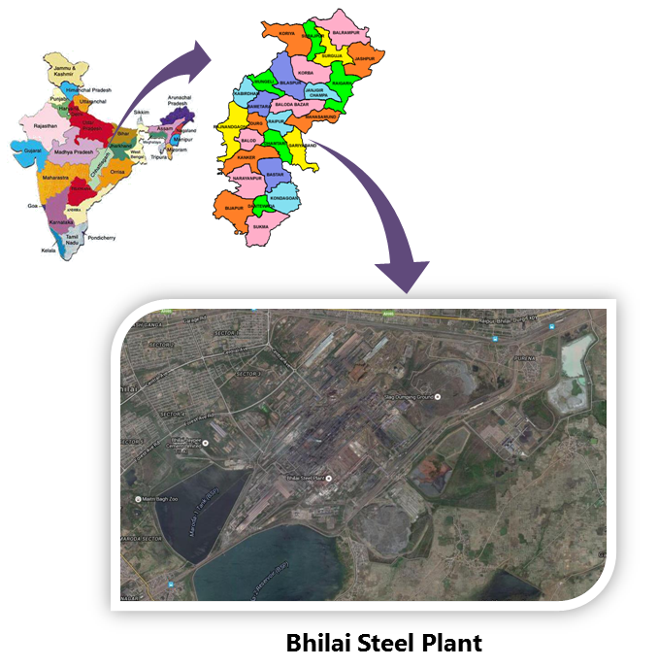

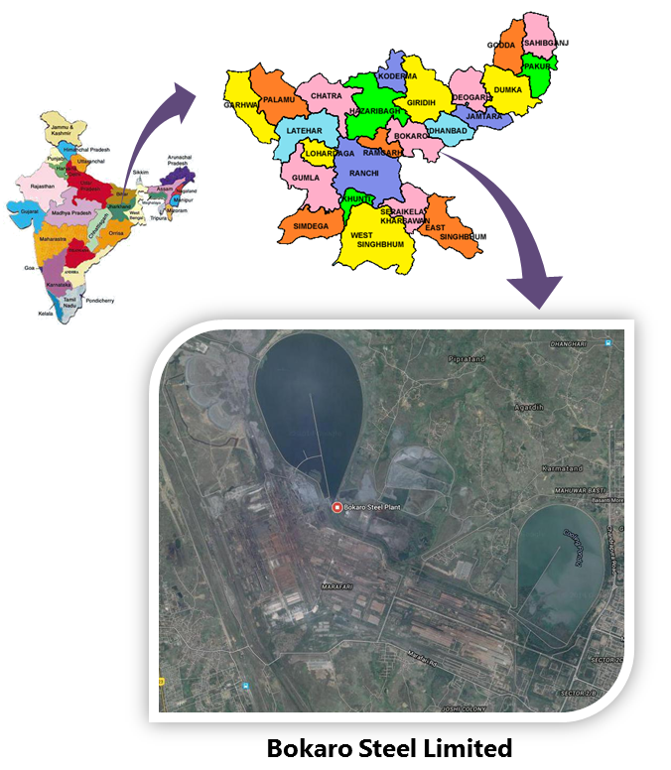

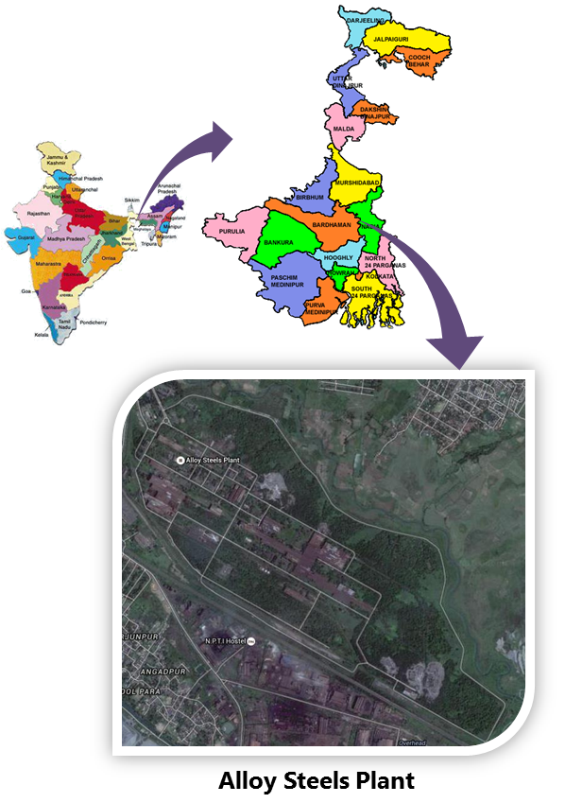

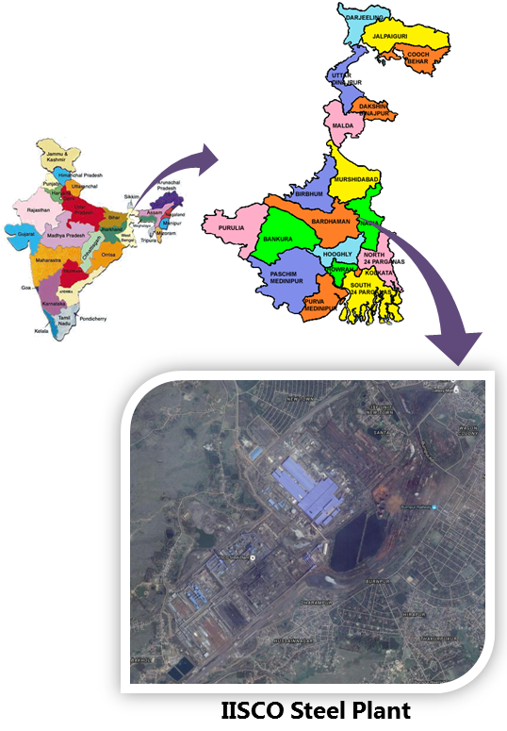

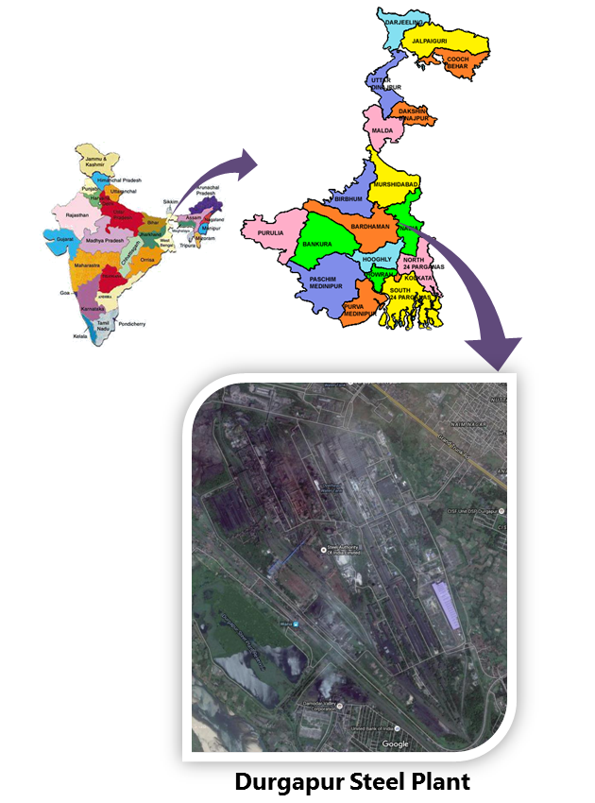

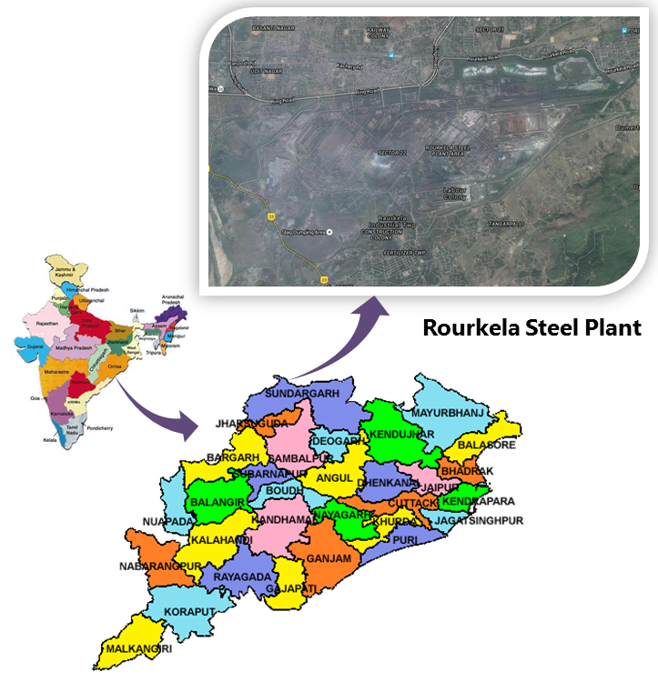

# General instructions to be observed:

## Pie-charts, bar charts or any suitable graphical representation shall be used to depict data wherever possible.

## Example:

## Costing may be represented as

## Components of data may be represented as (example shows various components of coal blend)

## Smart art in Microsoft word tab can be used. Word> Insert>Smart Art

## Charts in Microsoft word tab can be used. Word> Insert>Chart

## Example

## The line graph